RESOLUTION NO.__________

RE: CERTIFICATE OF APPROPRIATENESS UNDER THE
PROVISIONS OF THE ACT OF THE PENNSYLVANIA
LEGISLATURE 1961, JUNE 13, P.L. 282 (53
SECTION 8004) AND BETHLEHEM ORDINANCE NO.
3952 AS AMENDED.

The applicant proposes to remove an overhead garage door and replace with
three windows and new siding at 241 E. Market St.

NOW, THEREFORE, BE IT RESOLVED by the Council of the City of Bethlehem that a Certificate of Appropriateness is hereby granted for the proposal.

Sponsored by: (s)

(s)

ADOPTED BY COUNCIL THIS DAY OF

(s)
President of Council

ATTEST:

(s)
City Clerk

HISTORICAL & ARCHITECTURAL REVIEW BOARD

The applicant proposes to remove an overhead garage door and replace with three windows and new siding at 241 E. Market St.

APPLICATION #5:

Campbell Real Estate
241 E. Market St.
Bethlehem, PA 18018

OWNER:

__________________________________________________________________________

The Board upon motion by Connie Glagola and seconded by Phil Roeder adopted the proposal that City Council issue a Certificate of Appropriateness for the following:

- Approval for next phase of re-roofing.

2. All materials have been previously approved.

3. The motion was unanimously approved.

__________________________________________________________________________

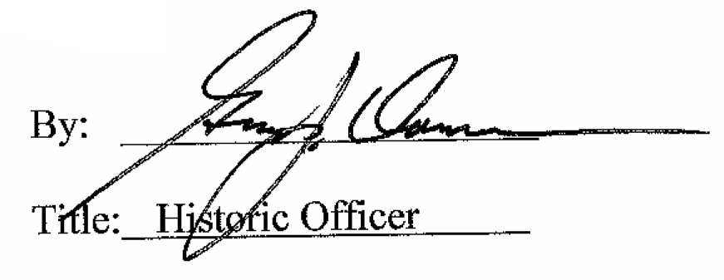

Date of Meeting: May 2, 2018

